**MoodSwing Gameplay Instructions**

Navigating

Use the mouse to navigate. Click and drag with the middle mouse button to rotate the view. Scroll the middle mouse button forwards and backwards to zoom in and out, respectively. Move the mouse to the edges of the screen or click and drag with the right mouse button to move around.

The User Interface

Click on the Swing Button to open the in-game menu. From there, you can quit to the main menu, or to Windows.



*The Swing Button*

The Mobs

People will be walking in and out of buildings in the city, probably to go to work.

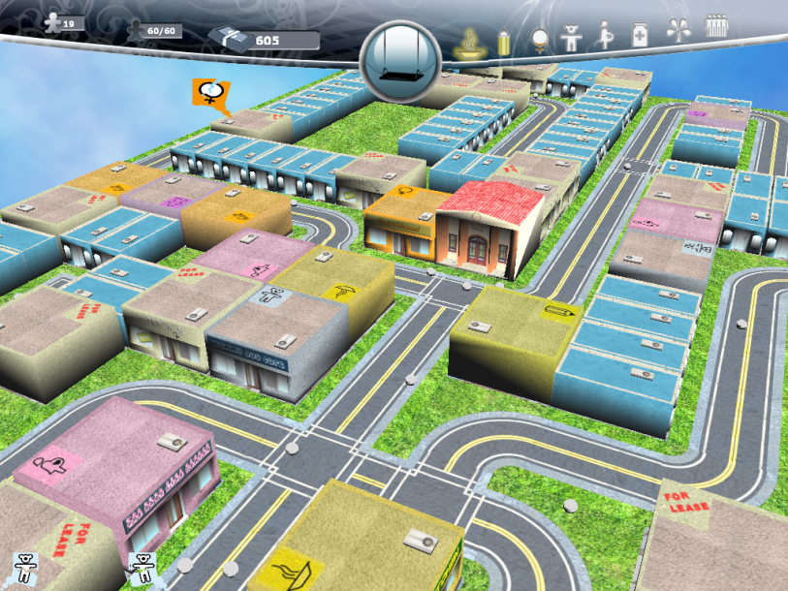

*People Walking Around the City*

Once in a while, certain people will walk out of buildings with a complaint about a specific issue. That person will complain about the lack of support given to one of the eight Millennium Development Goals. That person’s complaining will be indicated by a Mood Bubble.

While that person is walking, he may encounter other people in the city, tell them about their complaints, make them feel sad and angry, and convince them to be a part of his mob. Mobs will continue to walk toward the district hall and cause uproar. Mobs with specific complaints will appear in the same order as how the progress

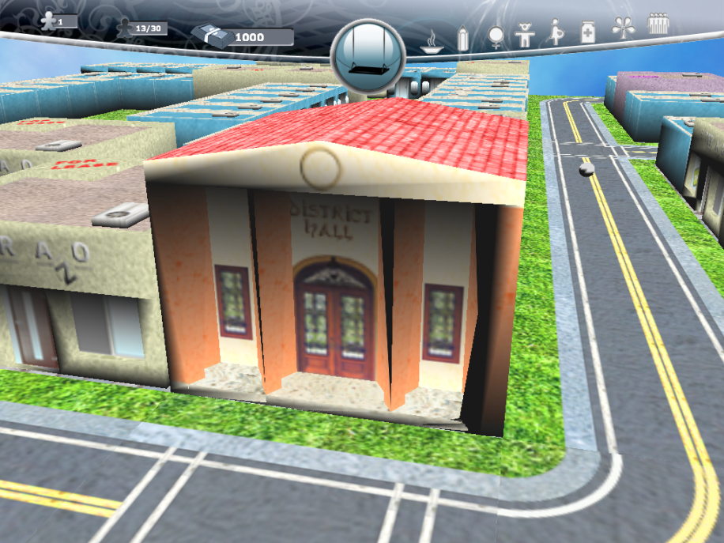

*District Hall*

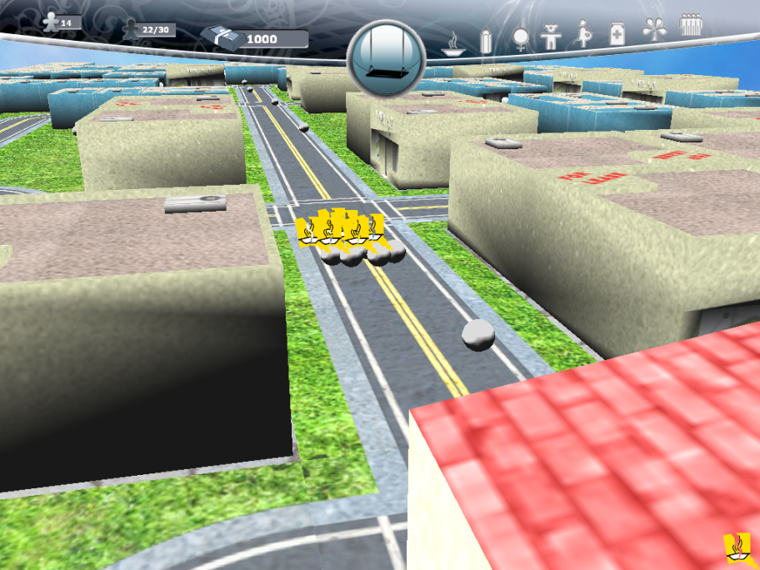

*Mob*

How to Win

Your goal is to address the issues of the mobs before they reach the district hall, serving as a mediator between the people and the city council.

To do that, you must build technological centers of development at various places in the city to catch the attention of the complaining people. First, click on a lot that is for sale.

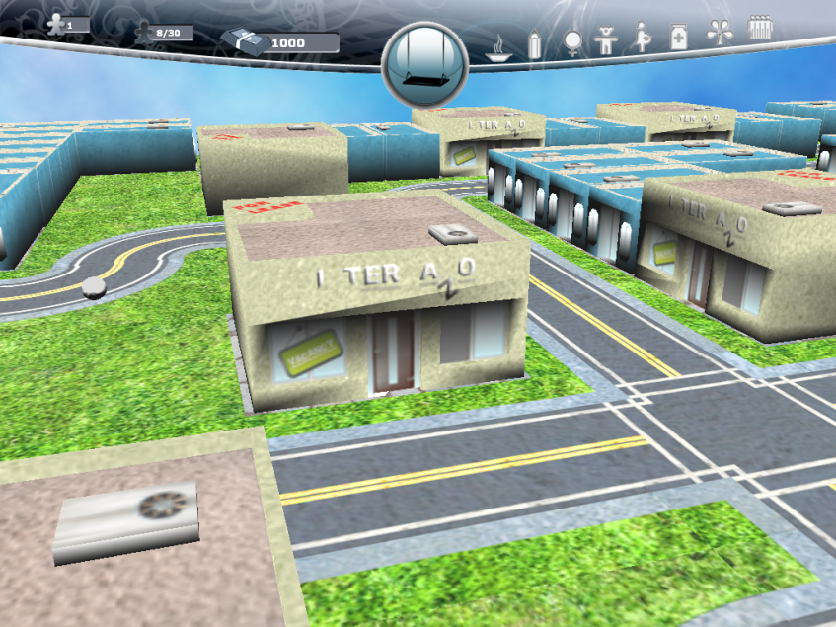

*Lot for Sale*

A circular picker will pop up and show the available centers which you may build. Choose which center you would like to build.

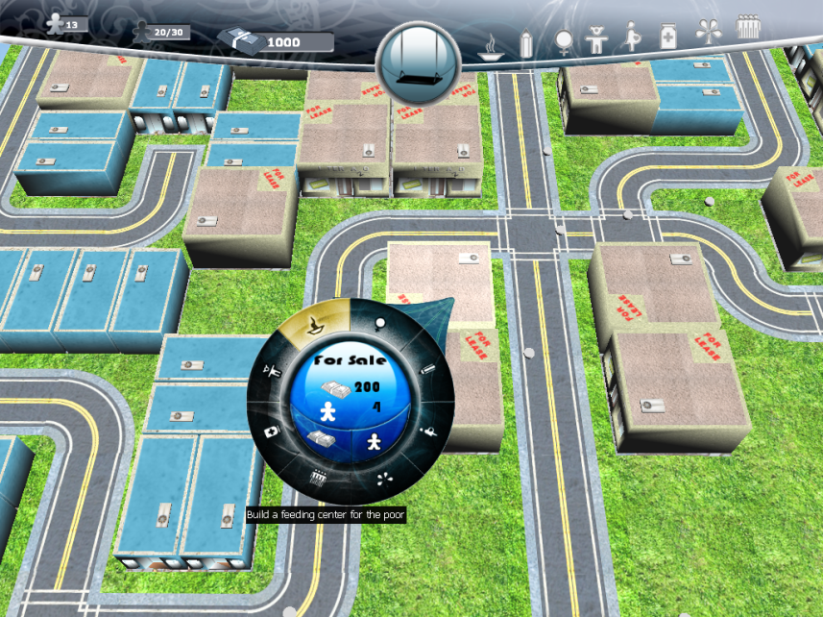

*Circular Picker*

Building centers require idle volunteers and funds. The corresponding costs will be shown in the middle of the circular picker. To gain volunteers and funds, you must build Volunteer Centers and Donation Centers, which can also be built from the Circular Picker.

**

*Building a Volunteer Center*

Once you have a Volunteer Center, volunteers will start joining your organization, and once you have a Donations Center, you will be able to start collecting donations from people who want to support your cause. The left side of the Game Panel shows three text boxes. The first box shows how many idle volunteers you currently handle. The second box shows how many total volunteers you currently handle over how many volunteers you currently are allowed to handle. And the third box shows how much funds you currently have. Building more Donation Centers will increase your funds generation, and building more volunteer centers will increase the number of volunteers you can handle.

Whenever you succeed in helping a sad, angry citizen, the progress bars on the right side of the Game Panel fills up. Once all of them are filled up, you win the game.

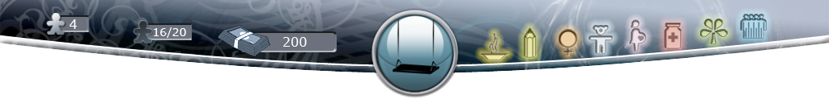

*Game Panel After All the Millennium Development Goals Have Been Achieved*

How to Lose

Mobs who aren’t given attention and eventually reach the district hall cause the Mood Level to go down. The Mood Level is indicated by the saturation of the district. Once the Mood becomes too bad, the game is over.

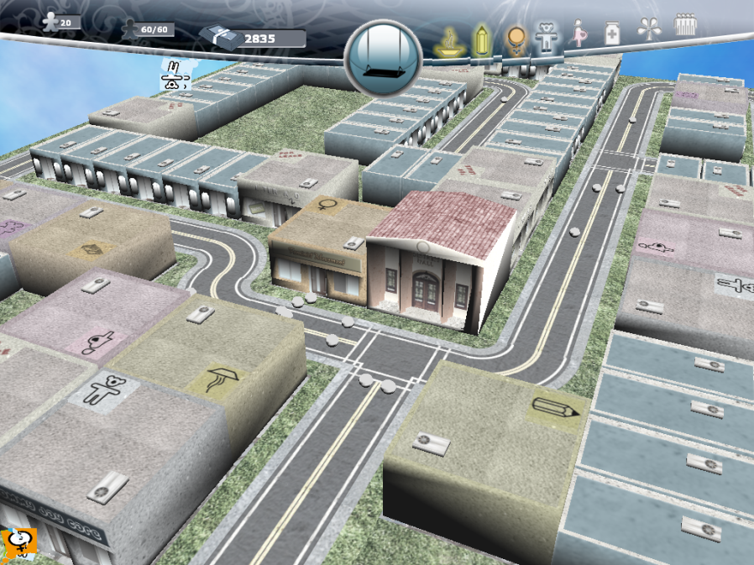

*The District in a Not-so-good Mood*